Requirement document

Process

We are using the Asset inventory under the PMS Admin module to track the assets, QR code process is implemented in the same

As a Process

We generate QR codes through Admin-Asset inventory process-inventory barcode, then the generated QR Codes are fixed on every asset.

The asset tracking can be done through scanning the QR code affixed on assets, for scanning we use the APK Manage assets, on scanning the QR code (using mobile phone) the details are populated to asset inventory module, same can be viewed by accessing the option Admin-Asset inventory process-inventory report as per below screenshot

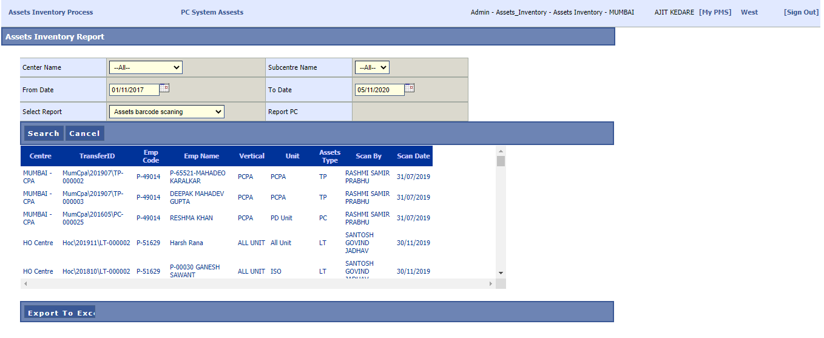

Requirement

1. to check the table in which the scanned details are stored
2. identify the Webservice used for APK
3. check the process of creating the userid for APK
4. scanning is randomly failing i.e. at some attempts scanned details are populated to database, at some attempts the same is not happening, we need to fix the same.